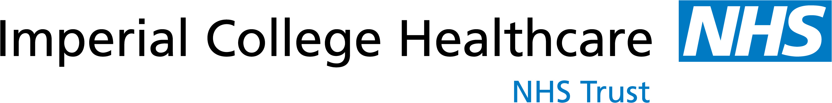

Antenatal Education Classes at St Mary’s Hospital
Our aim is to support expectant mothers and their families by providing information based on the current available evidence to enable them to make informed decisions about their care. Antenatal classes help you focus on your pregnancy and get you ready for labour and birth. The classes take place in the Parent Education Centre, Acrow Building, South Wharf Road W2 1NY.

The Healthy Pregnancy Class
The session covers exercise and relaxation in pregnancy, pelvic floor muscle exercises, dietary advice and lots more. You should aim to attend as early in your pregnancy as you can (ideally 12-16 weeks). This session is for pregnant women only, and not for partners.
To book this class please telephone 020 3311 5000.
Birth and Parenthood Preparation Classes
These classes help you to prepare for labour, birth and early parenthood. Topics covered include what to expect at the start of labour, how your birth partner can help, managing pain, different types of births and caring for a very young baby.
We offer a choice of either a three week course on Monday mornings or a one day class at the weekend. Your partner/birth partner is welcome to attend with you. You should aim to attend at 30 to 36 weeks of pregnancy but please phone to book your place once you are 24 weeks pregnant.
To book please telephone the Parent Education Centre on 020 3312 1402 and leave a message with your name, due date and phone number.
Breastfeeding Your Baby Class
The classes take place on selected Wednesday mornings and last two hours. You should aim to attend between 34-36 weeks of pregnancy. To find out the days and times of the classes please telephone the Parent Education Centre on 020 3312 1402 once you are 24 weeks pregnant.
Twins and Multiples
This session is only for women and their birth partners who are expecting twins or more. It consists of an evening talk and discussion time with a local twins club. You should aim to attend between 24-34 weeks of pregnancy. To book a place please telephone the Multiple Birth Foundation on 020 3313 3519. This session takes place in Queen Charlotte’s & Chelsea Hospital.

Infant Massage
In this class, you will learn how to gently massage your baby. Infant massage can help strengthen baby-parent communication, boost self-esteem and confidence in your parenting, and relax both parent and baby. Free baby massage courses are available through the Parent Education Centre at St Mary’s Hospital. Contact midwife Kate Shepherd at 020 3312 1402 for more information and to book a place.

